Data Flow Diagram and User Stories

|  |  |
| --- | --- |
| Team ID | PNT2022TMID37553 |
| Project Name | Analytics for Hospitals' Health-Care Data |

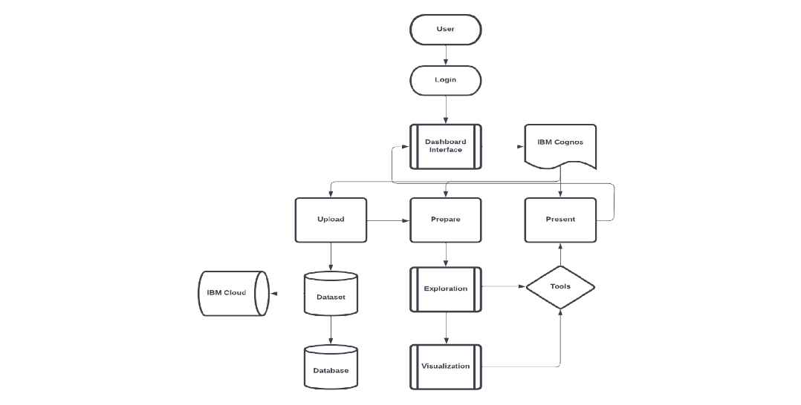

|  |  |  |  |  |  |  |
| --- | --- | --- | --- | --- | --- | --- |
| **S.NO** | **Funnctional**  **Requirements** | **User Story**  **Number** | **Tasks** | **Acceptance**  **Criteria** | **Priority** | **Release** |
| 1 | Data Gathering, | 1 | Gathering Data | Using API | High | Sprint1 |
| 2 | ,Pre-processing | 2 | Cleaning the data in proper format | Cleaned Data | High | Sprint 1 |
| 3 | Data Exploration | 3 | Explore the data | Display data in graph | High | Sprint1 |
| 4 | Dashboard | 4 | Creating various chart | Intractive Dashboard | High | Sprint 2 |
| 5 | Reports | 5 | Creating report for various field | Intractive  Report | High | Sprint 3 |
| 6 | Story | 6 | Creating Animation  Using picture | Various animation and slides | High | Sprint 4 |
| 7 | Web Appliction | 7 | Cognos Embeded  Web application | Intractive  Web Application | High | Sprint 4 |